#1: Create the library database and books table

CREATE DATABASE library;

USE library;

CREATE TABLE books (

id INT AUTO_INCREMENT PRIMARY KEY,

title VARCHAR(255),

author VARCHAR(100),

year YEAR,

genre VARCHAR(100));



#2: Insert the book records into the books table

INSERT INTO books (title, author, year, genre) values

('The Great Gatsby', 'F. Scott Fitzgerald', 1925, 'Fiction'),

('Pride and Prejudice', 'Jane Austen', 1913, 'Romance'),

('To Kill a Mockingbird', 'Harper Lee', 1960, 'Fiction'),

('1984', 'George Orwell', 1949, 'Dystopian'),

('Moby Dick', 'Herman Melville', 1951, 'Adventure');

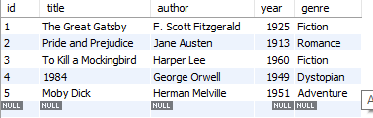

#3: Select all books where the title starts with 'T' using the LIKE operator

select * from books where title like 'T%';

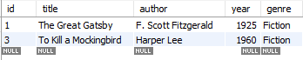

#4: Find all books where the author's last name ends with 'son' using the LIKE operator

select * from books where author like '%son';



# 5: Find all books where the title contains the word 'and' using the LIKE operator

select * from books where title like '%and%';



#6: Retrieve all books where the title ends with the word 'bird' using the LIKE operator

select * from books where title like '%bird';



#7: Find all books where the title has exactly 3 characters using the REGEXP operator

select * from books where title REGEXP '^.{3}$';



#8: Select all books where the title contains a number using the REGEXP operator

select* from books where title REGEXP '[0-9]';



#9: Retrieve all books where the author's name starts with any letter between 'A' and 'J' using the REGEXP operator

select * from books where author REGEXP '^[A-J]';

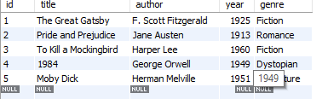

select *from books;

#10: Select all books where the genre is either 'Fiction' or 'Adventure' using the REGEXP operator

select * from books where genre REGEXP "Fiction|Adventure";

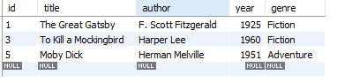

#11: Find all books where the title contains at least one uppercase letter using the REGEXP operator

select * from books where title REGEXP '[A-Z]';

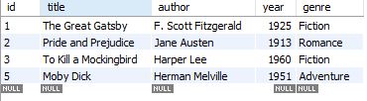

#12: Find all books where the year of publication is between 1800 and 1950 using the LIKE operator

select * from books where year LIKE '18%' OR year LIKE '19%';

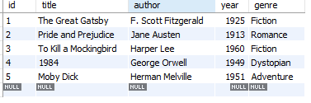

#13: Retrieve all books where the author's name contains exactly two words using the REGEXP operator

# 14: Find all books where the title starts with the letter 'P' and contains exactly two words using the REGEXP operator

#15: Find all books where the title contains any special characters using the REGEXP operator

# Mam I don't know how to give their command